2013 SIT AGM (Private Gentlemen’s Club est.1995)

Venue and date |  | Held at the Northcote Hotel, Francis Avenue, Southsea on 25th January 2013
Gentlemen present |  | Richard, Harry, Steve L, Bob, Steve O’C, Kim  Apologies from Alan and Steve Ol
Agenda |  | Review of last year’s minutes read by Richard whom then proceeded with the agenda. The Agenda format was as follows :-  Dates for 2013 monthly meetings and Review of 2012 attendance  Primary minutes : discussions on the open items from 2012  Secondary minutes : SIT account fund and Share Club  Tertiary minutes : open floor A.O.B.
Dates for 2011  Birthdays  Other dates  St Georges Day | - February  - Friday 22nd SIT meeting : venue Gosport Real Ale Winter Fest  - Steve O’c birthday 15th February 1961  - March  - Friday 22nd SIT meeting : venue Belle Isle, Osborne Road, Southsea  - April  - Friday 26th SIT meeting : venue Old Portsmouth, start at Bridge Tavern  - Steve Ol’s birthday 14th April 1961  - 23rd St Georges day  - May  - Friday 24th SIT meeting : venue Albert Road, start at Leopold  - Harry’s birthday 1st May 1961  - June  - Friday 28th SIT meeting : venue Belle Isle, Osborne Road, Southsea  - Sandra’s 50th birthday 29th June 1963  - July  - Friday 26th SIT meeting : venue All Bar One, Gun Wharf  - Richard’s birthday 2nd July 1961  - Alan’s birthday 13th July 1962  - August  - Friday 23rd SIT meeting : venue Old Portsmouth, start at Bridge Tavern  - September  - Friday 27th SIT meeting : venue Albert Road, start at Leopold  - Kim’s birthday September 1960  - Bob’s birthday 27th September 1960  - October  Friday 18th SIT meeting : Venue Emsworth, The Crown, Town Brewery etc.  - November  - Friday 22nd SIT meeting : venue Albert Road, start at Leopold  - Steve L birthday 5th November 1960  - December  - Friday 13th SIT meeting : venue Belle Isle, Osborne Road, Southsea  2014 AGM : Friday 24th January 2014  Venue : Northcote Hotel, Francis Avenue, Southsea
2013 SIT AGM (Private Gentlemen’s Club est.1995)

Meeting opened | The meeting opened at the Northcote Hotel, Francis Avenue, which has become the venue for the Annual General Meeting. Suitable comfortable seating for discussion was found and  roll call was taken with recorded apologises from Alan and Steve Ol.  The meeting was chaired by Richard who duly recorded the minutes.  A suitable kitty was opened for the members and drinks ordered from the lounge bar. Agendas, calendars, attendance records and non-audited SIT accounts were handed out for all members to peruse before the start of the meeting.
Review of 2012 attendance | The attendance records for 2012 showed 100% for Richard and Harry with Steve L and Steve O’c recording 92%, Bob 83%, Kim 75%, Steve Ol 50% and finally Alan with 42% attendance. December’s meeting was above average with 7 members attending a festive drink in Southsea. Although Steve Ol had little knowledge of how to use a diary he managed to attend 50 % of the meetings, with the missing 50% at double time on the ferry crossing from west Portsmouth to Lower Gosport in Hampshire.
 | Primary meeting points : Last year’s items
Steve Ol | Steve suggested various alternatives SIT meetings during the year.  Steve then offered the following as venues :
North End starting at the Fountain
Eastney : Starting at the Eastney Tavern and ending up at the Alma

Not carried out
Harry | Harry asked the group to consider a Christmas do with the girls this year. All agreed in principle and Harry and Steve L took on the challenge to organise something for the end of the year.  Not carried out
Steve L  Bob  Kim  Richard  Steve O’c  Share Club | Steve proposed a day out with the girls in London. A day trip similar to Sandra’s birthday trip would be ideal. Steve to investigate.  Not carried out  Bob promoted the Wedgewood rooms as a good additional night out to the current calendar. He will look out for bands that may suit the membership playing not only at the Wedgewood rooms but at other venues as well.  Not carried out  Kim brought to the meeting the dates for the Goodwood race meetings. Kim will attempt to arrange a day or evening at the races for the members  Some members participated in this event  Proposed a golf day out for those members interested in playing the game.  Not carried out  Proposed to organise a day on the Isle of Wight during the Cowes week.  Not carried out  Members can propose to purchase shares at any time thru the year using procedure : SIT 012 dated February 2010  No shares purchased from shares nominated by members
2013 SIT AGM (Private Gentlemen’s Club est.1995)

 | Secondary meeting points : SIT Account
SIT Account  Members fund  Share Dealer Account | Accounts were shown by Richard, showing contributions, tax and interest for the financial years 2004 - 2012.  The account balance to end of December 2012  Opening balance £7.58  Contributions £22,500.00  Interest £301.18  Bonds Winnings £975.00  Profit from Shares as of 31/12/11 £4.41  Total income £23,788.17  Tax on account -£46.14  Lotto purchases -£680.00  Accounting fees Richard FOC  Fund payout to 7 members -£12,460.00  Fund payout Cruise deposit -£2,100.00  Total outgoings -£15.286.14  Balance in account £8,502.03  Total SIT fund value £8,034.04 of which £3,000 has been put into a share club fund and £3,000 is currently in Premium Bonds  This equates to £1,214.58 per member as of 01/01/13  From this fund we will need to pay off the balance of the cruise which we belive to be approx. £3,500  A discussion forum was set up to decide on what to do with the share club and its fund.  Steve O’c explained that the Share Dealer Account has a value of £3,000 in sterling and No shares are currently held by the Share Club.  The members agreed to continue with the shares club and requested Steve O’c stay as primary driver for the purchase and control of future shares.  The procedure for proposing and procuring shares (Procedure No. SIT 012 dated February 2010) is already in place and should bebe used for all share tranmsactions.  The SIT account has a current total fund of £8,502.03 of which £3,004.41 is held in the share dealers account and £3,000 held in Premium Bonds.  Steve O’c will procure bonds from the emerging markets (Latin America) and report back to the group on our investments.  Premium bonds and winnings can be seen on the NS&I website, using link from SIT CLUB web site.
2013 SIT AGM (Private Gentlemen’s Club est.1995)

 | Tertiary meeting points : Open Floor A.O.B.
Harry | Harry invited the members and their partners to Sandra’s 50th Birthday party on June 29th.  The party will shared with Sandra’s friend Debbie and is going to be held at the caravan park in Eastney  Southsea Holiday & Leisure Park  Melville Road  Southsea  PO4 9TB
Steve L  Bob  Kim  Richard  Steve O’c | Steve proposed to arrange a day out clay pigeon shooting. Steve has become active in this sport and would like to share his experience with the group. Steve will look at setting up a corporate day for the SIT members.  Steve will continue to supervise the 2013 Cruise taking place in October and will organise transportation to the cruise terminal.  Bob will supervise the Gosport Real Ale Beer Winter fest being held in February. Most members have tickets with the exception of Alan and Steve Ol.  Richard offered assistance to Alan and Steve Ol as he would probably be visiting the Leopold before the 22nd Feb and can therefore get them tickets for the Gosport Winter Fest if required.  A request will go to Steve Ol to supply suitable return tickets for the ferry crossing.  Kim will attempt to arrange a day or evening at the races for the members. This will probably be during the Glorious Goodwood week. Although Kim’s record on horse racing organisation has not been up to much in previous years, the group were excited at Kim’s enthusiasm and encouraged that three members enjoyed a day’s racing last year.  Kim announced that he would be entering the Great South Run 2013 and would welcome other members to join him. This is part of his losing weight and keep fit campaign.  Members Harry and Richard voiced tentative acceptance of Kim’s offer.  Proposed a golf day out for those members interested in playing the game. Further details and proposed venues to be posted.  Steve explained that he will be looking for sponsorship this year. Steve is attempting to abseil down the Spinnaker Tower in Gun Wharf.  Steve will remind people at a later meeting of his chosen charity and sponsorship request.  Sandra’s 50th birthday 29th June 1963
2013 SIT AGM (Private Gentlemen’s Club est.1995)

SIT Account Balance Sheet as of 01 January 2013

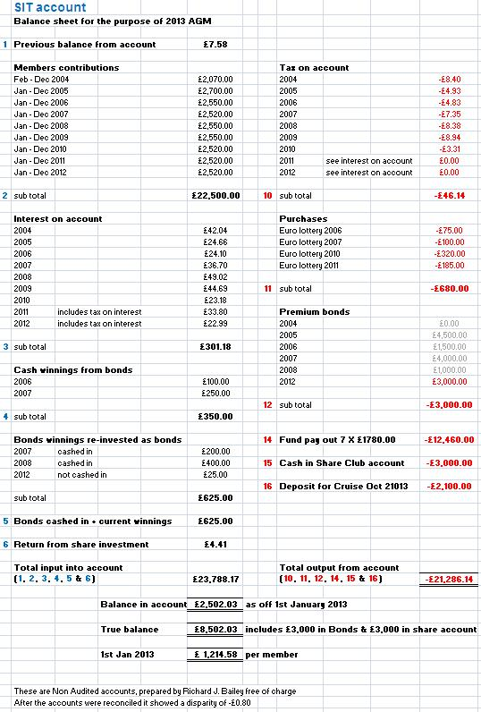
2013 SIT AGM (Private Gentlemen’s Club est.1995)

 |  | SIT Gentlemens Club attendance for 2012
 |  | Jan | Feb | Mar | Apr | May | Jun | Jul | Aug | Sep | Oct | Nov | Dec
 |  | AGM Northcote | Southsea | Southsea | Old Portsmouth | Albert Road | Southsea | Fawcet Road | Old Portsmouth | Albert Road | Southsea | Albert Road | Southsea
Rich | 100%
Al | 42%
Steve L | 92%
Harry | 92%
Bob | 83%
Steve Ol | 50%
Steve O'C | 92%
Kim | 75%
 |  | Jan | Feb | Mar | Apr | May | Jun | Jul | Aug | Sep | Oct | Nov | Dec
% attendance and number of members |  | 88 | 88 | 100 | 75 | 75 | 62 | 50 | 75 | 88 | 62 | 88 | 88
 |  | 7 | 7 | 8 | 6 | 6 | 5 | 4 | 6 | 7 | 5 | 7 | 7

Note : Harry corrected data on chart shown at AGM declaring non attendance during November SIT meeting.

Date for 2014 AGM | Friday 26th January : venue Northcote Hotel, Francis Avenue, Portsmouth
Richard called the meeting to a close and the members strolled to the Leopold to purchase Beer Fest tickets and enjoy further refreshment and merriment.

Written by Richard J. Bailey
Checked By Steve O’Connor
28th January 2013

