2014 SIT AGM
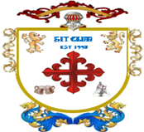
(Private Gentlemen’s Club est.1995)

Venue and date |  | Held at the Northcote Hotel, Francis Avenue, Southsea on 24th January 2014
Gentlemen present |  | Richard, Harry, Steve L, Bob, Steve O’C, Kim, Alan and Steve Ol
Agenda |  | Review of last year’s minutes read by Richard whom then proceeded with the agenda. The Agenda format was as follows :-  Dates for 2014 monthly meetings and Review of 2013 attendance  Primary minutes : discussions on the open items from 2013  Secondary minutes : SIT account fund and Share Club  Tertiary minutes: open floor A.O.B.
Dates for 2014  Birthdays  Other dates  St Georges Day | - February  - Friday 21st SIT meeting : venue Gosport Real Ale Winter Fest  - Steve O’C birthday 15th February 1961  - March  - Friday 28th SIT meeting : venue Albert Road, start at Leopold  - April  - Friday 25th SIT meeting : venue Red White & Blue, Fawcett Road  - Steve Ol’s birthday 14th April 1961  - 23rd St Georges day  - May  - Friday 30th SIT meeting : venue Emsworth, start at The Crown  - Harry’s birthday 1st May 1961  - June  - Friday 20th SIT meeting : venue Belle Isle, Osborne Road, Southsea  - Sandra’s 50th birthday 29th June 1963  - July  - Friday 18th SIT meeting : venue Albert Road, start at Leopold  - Richard’s birthday 2nd July 1961  - Alan’s birthday 13th July 1962  - August  - Friday 29th SIT meeting : venue Old Portsmouth, start at Bridge Tavern  - September  - Friday 26th SIT meeting : venue Belle Isle, Osborne Road, Southsea  - Kim’s birthday September 1960  - Bob’s birthday 27th September 1960  - October  - Friday 24th SIT meeting : Venue Gun Wharf, start at All Bar One  - November  - Friday 21st SIT meeting : venue Albert Road, start at Leopold  - Steve L birthday 5th November 1960  - December  - Friday 19th SIT meeting : venue To be Arranged  2015 AGM : Friday 23rd January 2015 : 20 year  Venue : Northcote Hotel, Francis Avenue, Southsea
2014 SIT AGM
(Private Gentlemen’s Club est.1995)

Meeting opened  Letter of Beginning | The meeting opened at the Northcote Hotel, Francis Avenue, promptly at 7:30 with all members present. Suitable comfortable seating for discussion was found in a corner of the Lounge bar and roll call was taken.  The meeting was chaired by Richard who duly recorded the minutes.  A suitable kitty was opened for the members and drinks ordered from the lounge bar. Agendas, calendars, and non-audited SIT accounts were handed out for all members to peruse before the start of the meeting. Unfortunately attendance records were missing for the members packs for which Richard apologised. The attendance records can be found attached to these minutes.  Before the meeting stated in earnest, Kim produced a letter that he had sent to members on 10th March 1995. The letter was the initial driver for the birth of the Stay In Touch club. The letter shows that the first meeting was held at the George Inn on Wednesday 22nd March 1995. This letter is attached to these minutes. Steve O’C to make it available on the SIT web site along with our Coat of Arms.
Review of 2013 attendance | The attendance records for 2013 show only one member, Steve O’C achieving a 100% attendance. Richard and Harry recorded 11 meetings attended with Steve L attending 10 meetings. Other member’s attendances were Kim 75%, Bob 58%, Steve Ol 50% and finally Alan with 42% attendance. These figures were much the same as last year. April was the only month that produced a full house of members.
 | Primary meeting points : Last year’s items
Harry | Harry asked the group to attend Sandra’s 50th Birthday party at the ROKO Health Club.  Successfully attended by the membership
Steve L  Bob  Kim  Richard  Share Club | Steve proposed a day out clay pigeon shooting. Steve was to organise a corporate day for the members.  Not carried out  Steve would continue to supervise and organise the October Cruise trip including transport by Limo  This was successfully carried out but the cruise ended up as a simple ferry crossing.  Bob promoted the Gosport Real Ale Winter fest.  Successfully attended by the membership  Kim brought to the meeting the dates for the Goodwood race meetings. Kim would attempt to arrange a day or evening at the races for the members  Not carried out  Proposed a golf day out for those members interested in playing the game.  Not carried out  Members could propose to purchase shares at any time thru the year using the written procedure : SIT 012 dated February 2010  No shares purchased from shares nominated by members  The existing shares in the First State Latin American market were retained
2014 SIT AGM
(Private Gentlemen’s Club est.1995)

 | Secondary meeting points : SIT Account
SIT Account  Members fund  Share Dealer Account | Accounts were shown by Richard, showing contributions, tax and interest for the financial years 2004 - 2013.  The account balance to end of December 2012  Opening balance £7.58  Contributions £25,020.00  Interest £319.07  Bonds Winnings £975.00  Total income £26,321.65  Tax on account -£46.14  Lotto purchases -£680.00  Accounting fees Richard FOC  Fund payout to 7 members -£12,460.00  Fund payout Cruise deposit -£9,502.00  Loss on shares as of 16/01/2014 -£388.00  Total outgoings -£23,076.12  Balance in account £3245.53  Total SIT fund value £3,245.53 of which £2,612.00 is the current value of the SIT club shares.  This equates to £463.65 per member as of 01/01/13  A discussion forum was set up to decide on what to do with the share club and its fund.  Steve O’C explained that the current fund has not performed very well in the emerging markets of Latin America (First State Latin American fund). The current fund is down 12.9% which equates to £388.00 of the intiall £3,00.00 investment.  There were no additional rerquest to purchase share / bonds throught last year.  Ref to procuring shares (Procedure No. SIT 012 dated February 2010)  The SIT account has a current share fund value of £2,617.00  Discussions took place on the share and their performance and if the shares should be moved or cashed in.  Steve Ol informed the group that shares not performing should be given a chance and that we should retain them with possible future growth thru 2014.  Steve O’C proposed that we should see how the funds perfom thru 2014 but as a bit of security remove 50% of the value back into the SIT account.  Richard and Steve L proposed the shares are cashed in and Premium Bonds purchased.  Richard proclaimed that the share club was not really working for us as we had planned. To back this up he said that not one member suggested that we purchase Post Office or Twitter shares.
2014 SIT AGM
(Private Gentlemen’s Club est.1995)

Share Dealer Account  (continued) | The group were invited to make a vote on the shares and their value.  - Keep 100% of the shares and track them thru 2014  - Withdraw 50% of the shares value, but track the shares thru 2014  - Cash in all the shares and purchase NS&I Premium Bobnds.  The result of the vote was to cash the shares in and purchase Premium Bonds.  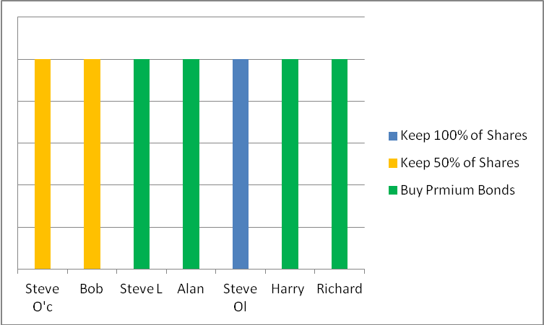  Steve O’C to action this and will liaise with Richard on the procurenmet of NS&I Premium Bonds. Richard will purchase bonds in quantities of £100 with the balance (currently £17.00) being returned to the Cahoot account.
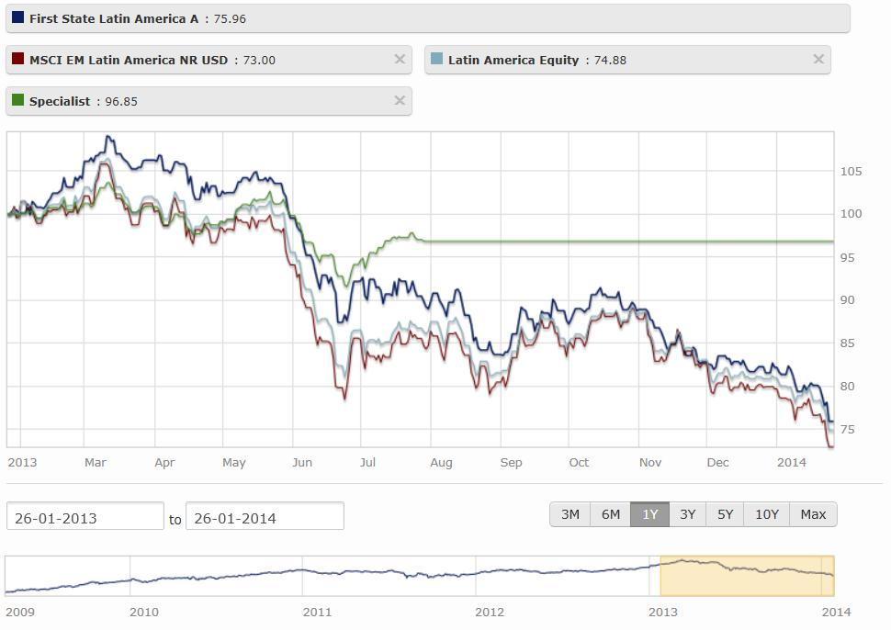
%

2014 SIT AGM
(Private Gentlemen’s Club est.1995)

All  Whisky Trip  Harry  Steve L  Richard  Bob  Kim | Tertiary meeting points : Open Floor A.O.B.  The group spoke openly about Kim’s letter date 10th March 1995, which was to be the birth of the SIT Club.  A discussion took place on what to do for the 20th anniversary of the club. Several suggestions were tabled for events / venues in the summer of 2015.  After much deliberation the general consensus was to have a boy’s weekend beano somewhere warm to play golf and drink fine wine. Further suggestions and arrangements to be made before the end of this year.  The group also inquired about the possibility of all members attending the Whisky trip that Richards brother Michael arranges. Last year saw some of the group take part in the trip to the island and sample some fine malts and blends which concluded at Old Portsmouth.  Richard will enquire on behalf of the group on the possibility of joining the trip.  Harry invited the members to a forthcoming boxing event. The venue will be local and in May time. Harry will arrange and call upon members nearer the time when he has more information.  Steve proposed to arrange a day out clay pigeon shooting. Steve has become active in this sport and would like to share his experience with the group. Steve will look at setting up a corporate day for the SIT members at the Wallers Ash Gun Club. Date to be advised.  Richard will attempt to organise a Golf day out for those members wishing to play. Richard will advise once the climate changes for the better.  Bob promoted the Winterfest XXII Gosport's Winter Beer Festival being held on Friday 21st February. Bob suggested this would be a good venue for the February SIT meeting.  Richard offered assistance in purchasing members tickets as he would probably be visiting the Leopold before the 21st Feb and can therefore get them tickets for the Gosport Winter Fest if required. Other pubs selling tickets are the Hole in The Wall and the Winchester Arms.  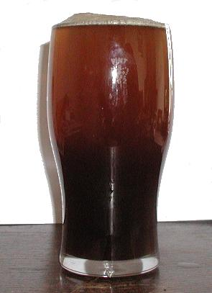  A request will go to Steve Ol to supply suitable return tickets for the ferry crossing.  Kim will once again try to organise a day racing at Goodwood Racecourse. Kim will look at race dates this year with a view of travelling up by train and then bus to the course.  Kim also promoted the idea of a Sunday lunch during the summer with the girls. Somewhere accessible to all with a long relaxing afternoon of food and fine wine.
2014 SIT AGM
(Private Gentlemen’s Club est.1995)

Copy of Kim’s letter dated 10th March 1995

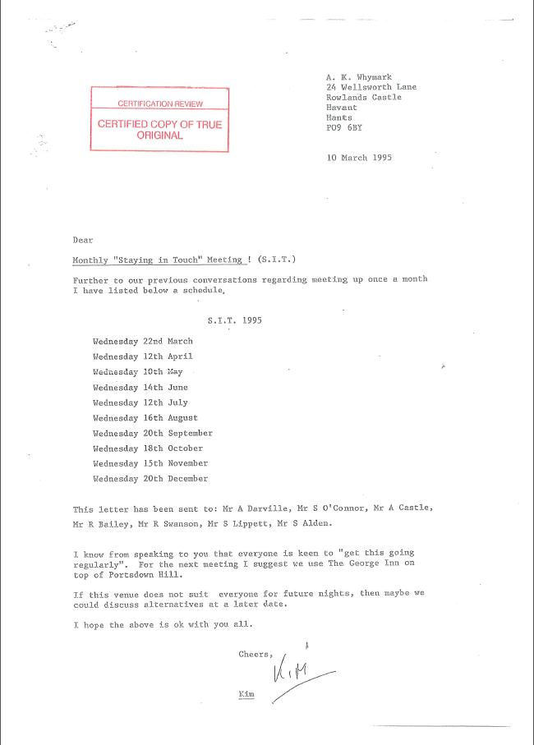
2014 SIT AGM (Private Gentlemen’s Club est.1995)

 |  | SIT Gentlemen’s Club attendance for 2013
 |  | Jan | Feb | Mar | Apr | May | Jun | Jul | Aug | Sep | Oct | Nov | Dec
 |  | AGM Northcote | Gosport beer festival | Southsea | Old Portsmouth | Albert Road | Southsea | Gun Wharf | Old Portsmouth | Albert Road | Whiskey Trip Old Portsmouth | Albert Road | Southsea
Rich | 92%
Al | 42%
Steve L | 83%
Harry | 92%
Bob | 58%
Steve Ol | 50%
Steve O'C | 100%
Kim | 75%
 |  | Jan | Feb | Mar | Apr | May | Jun | Jul | Aug | Sep | Oct | Nov | Dec
% attendance and number of members |  | 75 | 88 | 75 | 100 | 75 | 88 | 50 | 75 | 62 | 75 | 75 | 50
 |  | 6 | 7 | 6 | 8 | 6 | 7 | 4 | 6 | 5 | 6 | 6 | 4

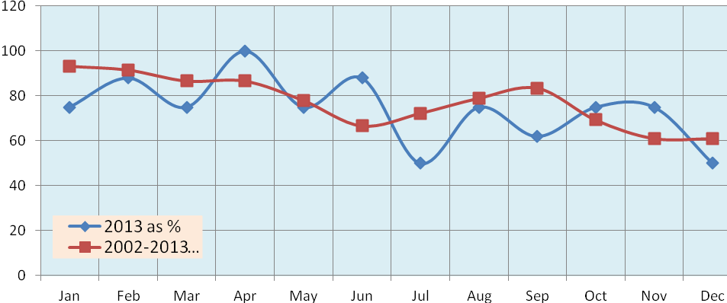
Richard called the meeting to a close and due to the inclement weather the members stayed at the Northcote Hotel for further drinks and conversation

Written by Richard J. Bailey
Checked By Steve O’Connor
28th January 2014

