2015 SIT AGM
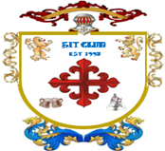
(Private Gentlemen’s Club est.1995)

Venue and date |  | Held at the Northcote Hotel, Francis Avenue, Southsea on 23rd January 2014
Gentlemen present |  | Richard, Harry, Steve L, Bob, Steve O’C, Kim, Alan and Steve Ol
Agenda |  | Review of last year’s minutes read by Richard whom then proceeded with the agenda. The Agenda format was as follows :-  Dates for 2015 monthly meetings and Review of 2014 attendance  Primary minutes : discussions on the open items from 2014  Secondary minutes : SIT account fund  Tertiary minutes : open floor A.O.B.
Dates for 2014  Birthdays  Other dates  St Georges Day | - February  - Friday 27th SIT meeting : venue Albert Road, start at Leopold  - Steve O’c birthday 15th February 1961  - March  - Saturday 29th SIT meeting : venue London (TBA by Steve L)  - April  - Friday 24th SIT meeting : venue Belle Isle, Osborne Road, Southsea  - Steve Ol’s birthday 14th April 1961  - 23rd St Georges day  - May  - Friday 29th SIT meeting : venue Albert Road, start at Leopold  - Harry’s birthday 1st May 1961  - June  - Friday 26th SIT meeting : venue Belle Isle, Osborne Road, Southsea  - July  - Friday 31st SIT meeting : venue Albert Road, start at Leopold  - Richard’s birthday 2nd July 1961  - Alan’s birthday 13th July 1962  - August  - Friday 28th SIT meeting : venue Old Portsmouth, start at Bridge Tavern  - September  - Friday 25th SIT meeting : venue Belle Isle, Osborne Road, Southsea  - Kim’s birthday September 1960  - Bob’s birthday 27th September 1960  - October  - Friday 30th SIT meeting : Venue Gun Wharf, start at All Bar One  - November  - Friday 27th SIT meeting : venue Albert Road, start at Leopold  - Steve L birthday 5th November 1960  - December  - Friday 18th SIT meeting : venue To be Arranged  2016 AGM : Friday 22nd January 2016 : year 21  Venue : Northcote Hotel, Francis Avenue, Southsea
2014 SIT AGM
(Private Gentlemen’s Club est.1995)

Meeting opened  Members Photograph | The meeting opened at the Northcote Hotel, Francis Avenue, promptly at 7:30 with all members present. Suitable comfortable seating in a corner of the Lounge bar for discussion was secured by Kim whom arrived slightly earlier than other members and roll call was taken. All members were present and on time.  The meeting was chaired by Richard who duly recorded the minutes.  A suitable kitty was opened for the members and drinks ordered from the lounge bar. Agendas, calendars, and non-audited SIT accounts were handed out for all members to peruse before the start of the meeting.  Steve O then without formal notice to the members, arranged for a group photo to be taken by one of the guest in the pub.
Review of 2014 attendance | The attendance records for 2014 showed only one member, Steve O’c, once again achieving a 100% attendance. Richard recorded 11 meetings attended last year with Harry and Steve L attending 9 meetings. Other member’s attendances were Steve Ol 67%, Bob 58%, Kim 42%, and finally Alan with 25% attendance. The only month that produced a full house of members was January AGM with December a good 7/8. The summer months of July – Sept performed well with 75% attendance.  Graphical display of attendance can be found below.
Harry  Steve L  Bob  Kim  Richard | Primary meeting points : Last year’s items  Harry invited everyone to a boxing event. Local venue in May.  Not carried out  Steve proposed a day out clay pigeon shooting. Steve was to organise a corporate day for the members at the Wallers Ash Gun Club.  Not carried out  Bob promoted the Gosport Real Ale Winter fest.  Notification of the Winter Fest was announced by Bob but only Bob went.  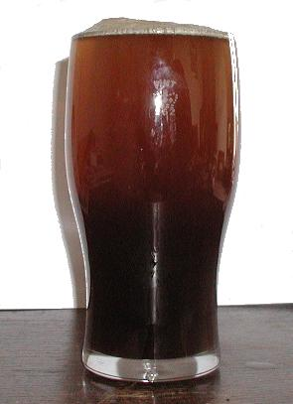  Kim agreed to organise a day or evening at the races for the members. Kim proposed Glorious Goodwood but would look into other Goodwood meetings.  Not carried out But Kim did prepare of offer some dates of race meetings  Kim promoted the idea of a Sunday lunch during the summer with the girls  Not carried out  Proposed a golf day out for those members interested in playing the game.  Not carried out
2014 SIT AGM
(Private Gentlemen’s Club est.1995)

 | Secondary meeting points : SIT Account
SIT Account  Members fund  SIT Account Investment’s | Accounts were shown by Richard, showing contributions, tax and interest for the financial years 2004 - 2014.  The account balance to end of December 2014  Opening balance £7.58  Contributions £27,510.00  Interest £333.73  Bonds Winnings £1050.00  Total income £28,901.31  Tax on account -£46.14  Lotto purchases -£680.00  Premium Bonds purchase -£1,800.00  Accounting fees Richard FOC  Fund payout to 7 members -£12,460.00  Fund payout Cruise deposit -£9,502.00  Loss on shares -£470.00  Total outgoings -£24,958.14  Balance in account £3943.17  Total SIT fund value £5818.17 of which £1,875 is in Premium Bonds.  This equates to £831.17 per SIT Account member as of 01/01/15  The SIT account has £1,875.00 invested in Premium Bonds  £75.00 of which is winnings from 2014 re-invested as bonds
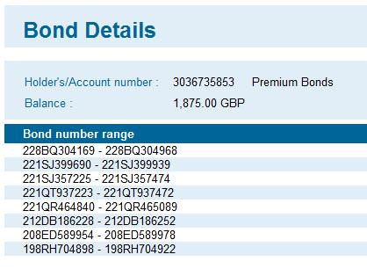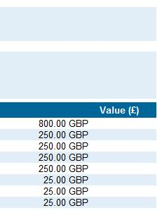

2014 SIT AGM
(Private Gentlemen’s Club est.1995)

Richard  Harry  Steve L  Bob  Kim  Steve O  Steve Ol  Alan | Tertiary meeting points : Open Floor A.O.B.  Richard invited the group take part in the annual Whisky trip being arranged by his brother Michael. A sample some fine malts and blends will be available to taste and experience probably in the Emsworth or Wickham area. A coach will be laid on for the day and return to Portsmouth as some stage. Richard will announce the date and venues shortly.  Richard will arrange and advise on an evening at the Watermark, Port Solent for a belated Christmas party for the membership and their wives / guests.  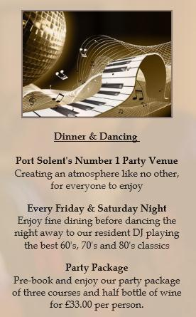  Harry had no other business  Steve proposed to arrange a day out clay pigeon shooting. Steve will look at setting up a corporate day for the SIT members at the Wallers Ash Gun Club. Date to be advised.  Bob promoted the Winterfest XXIII Gosport's Winter Beer Festival again. This year there will be having over 100 different real ales, traditional ciders and international bottled beers. The festival is on Friday 20th & Saturday 21st February at Thorngate Hall in Gosport.  Bob also suggested another festival this being the Southsea Beerex. The event is being held at the Wedgewood Rooms from March 20 and 21 and is the mastermind of Stuart Ainsworth, landlord of The Leopold Tavern. Around 80 different ales and a selection of cider and bottled beers will be on offer for thirsty punters.  Kim admitted he missed most of the points debated but was Happy.  Steve he was having a BBQ type afternoon party in early June. Date to be advised.  Steve recommended a Comedy Club night at the Spinnaker Tower in December.  Alan wants the membership to get together and arrange for a going away beano next year. The group agreed that this should be investigated and booked soon.

2014 SIT AGM (Private Gentlemen’s Club est.1995)

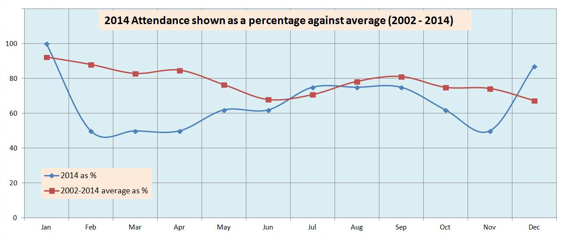

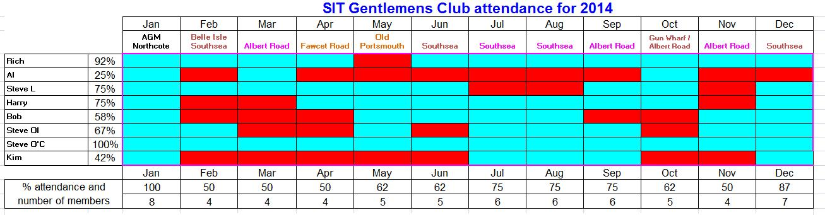
Richard called the meeting to a close and due to the inclement weather the members stayed at the Northcote Hotel for further drinks and conversation

Written by Richard J. Bailey Checked By Steve O’Connor
26th January 2015

