2018 SIT AGM
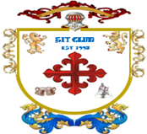
(Private Gentlemen’s Club est.1995)

Venue and date |  | Held at the Northcote Hotel, Francis Avenue, Southsea on 19th January 2018
Gentlemen present |  | Richard, Harry, Steve L, Bob, Steve O’C, Kim, Alan and Steve Ol
Agenda |  | Review of last year’s minutes read by Richard who then proceeded with the agenda. The Agenda format was as follows :-  Dates for 2018 monthly meetings and Review of 2017 attendance  Primary minutes : discussions on the open items from 2017  Secondary minutes : SIT account fund  Tertiary minutes : open floor A.O.B.
Dates for 2018  Birthdays  Other dates  St Georges Day | - February  - No meeting in February see double meeting arranged in March  - Steve O’c birthday 15th February 1961  - March  - Friday 2nd SIT meeting : venue Southsea, start at Belle Isle  - Thursday 29th SIT meeting : venue Albert Road, start at Porters  - April  - Friday 27th SIT meeting : venue Southsea, start at Belle Isle  - Steve Ol’s birthday 14th April 1961  - 23rd St Georges day  - May  - Friday 25th SIT meeting : venue Albert Road, start at Porters  - Harry’s birthday 1st May 1961  - June  - Friday 29th SIT meeting : venue Old Portsmouth, start at Still & West  - July  - Friday 27th SIT meeting : venue Southsea, start at Belle Isle  - Richard’s birthday 2nd July 1961  - Alan’s birthday 13th July 1962  - August  - Friday 31st SIT meeting : venue Old Portsmouth, start at Bridge Tavern  - September  - Friday 28th SIT meeting : venue Southsea, start at Belle Isle  - Kim’s birthday September 1960  - Bob’s birthday 27th September 1960  - October  - Friday 26th SIT meeting : venue Albert Road, start at Porters  - November  - Friday 23rd SIT meeting : Southsea, start at Red White & Blue  - Steve L birthday 5th November 1960  - December  Friday 21st SIT meeting : venue Southsea, start at Belle Isle  2019 AGM : Friday 18th January 2019 : year 24  Venue : Northcote Hotel, Francis Avenue, Southsea
2018 SIT AGM
(Private Gentlemen’s Club est.1995)

Meeting opened | The meeting opened at the Northcote Hotel, Francis Avenue, promptly at 8:00 with all members present. Suitable comfortable seating in the Lounge bar for discussion and roll call was taken. All members were present and on time. AGM corner taken by some Non-Members, as was opposite corner, so seating adjacent to the door was preferred. Do they not know who we are!  The meeting was chaired by Richard who duly recorded the minutes.  A suitable kitty was opened for the members and drinks ordered from the lounge bar. Agendas, calendars, and non-audited SIT accounts were handed out for all members to peruse before the start of the meeting.
Review of 2017 attendance  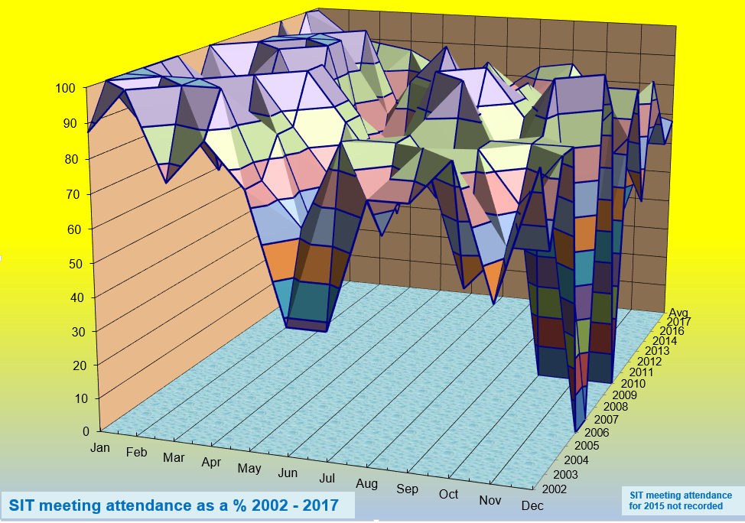 | The attendance records for 2017 were reviewed. Graphical display of attendance was debated with members. It was recorded that only Richard achieved all 12 meetings, with Steve L & Bob 11 of 12 meetings, Harry 10 and Steve O 9 of 12 meetings. It was shown that members who fell below 50% were Alan 4 meetings and Kim only 2. Steve Ol went to half the meetings thru 2018. There was only one month were all 8 members managed to meet and that was the January AGM. The average attendance thru 2017 was 67% of members present. (see below)
Primary meeting points : Last year’s items

Items that were carried out :
(Proposers in brackets)

- SIT subscription to increase to £40 per month from £30 (All)
- Removal of reference to GITs Club from SIT website banner (Kim)
- Lottery ticket money to come from SIT account (to Alans account) (All)
- Whisky trip (Richard)
- Day out to the cricket to see England v W Indies ODI (Steve O)

None of the following were actioned :
(Proposers in brackets)

- All day SIT meeting to start at 3 O’clock (Kim)
- Evening at a comedy club for one of the SIT meetings (Steve Ol)
- Summer garden party with ladies (Harry)
- SIT meeting at a restaurant followed by Gin/Beer etc. (Harry)
- Weekend away to sunny Europe (Alan)
- Shooting Day (Steve L)

2017 SIT AGM
(Private Gentlemen’s Club est.1995)

 | Secondary meeting points : SIT Account
SIT Account  Members fund | Accounts were shown by Richard, showing contributions, tax and interest for the financial years 2004 - 2017.  The account balance to end of December 2017  Opening balance £7.58  Contributions £35,910.00  Interest £345.49  Bonds Winnings £925.00  Total income £37,188.07  Tax on account -£46.14  Lotto purchases -£680.00  Premium Bonds purchase -£5,000.00  Accounting fees Richard FOC  Fund payout to 7 members (Vegas) -£12,460.00  Fund pay out Cruise / London -£12,488.28  Xmas meal -£702.25  Lotto tickets -£780.00  Loss on shares -£470.00  Total outgoings -£32,629.67  Balance in account £4,558.40  Total SIT fund value £9,558.40 of which £5,000 is in Premium Bonds.  This equates to £1,365.49 per SIT Account member as of 01/01/18  Tertiary meeting points : Open Floor A.O.B.  Steve L will arrange another Shooting event, on a Sunday morning for those wishing to attend.  Steve O suggested a SIT meeting could be at a 20/20 Cricket match at the Ageas Bowl (Hampshire CC)  Steve O & Steve OL promoted a visit to Cowes during the Lendy Cowes Week sailing regatta. Dates suggested were Thursday 9th or Friday 10th August  Alan reminded the membership that we were all agreed on a weekend away and once again was prepared to look into this event and asked everyone for dates that they would not be able to go thru 2018.
Meeting called to a close.
Meeting minutes written by Richard and checked by Steve O’C 6th Jan 2018

Attendance graph below

