2019 SIT AGM

(Private Gentlemen’s Club est.1995)

Venue and date |  | Held at the Northcote Hotel, Francis Avenue, Southsea on 1st February 2019
Gentlemen present |  | Richard, Harry, Steve L, Bob, Steve O’C, Kim, Alan and Steve Ol
Agenda |  | Review of last year’s minutes read by Richard who will then proceeded with the agenda. The Agenda format was as follows :-  Dates for 2019 monthly meetings and Review of 2018 attendance  Primary minutes : discussions on the open items from 2018  Secondary minutes : SIT account fund  Tertiary minutes : open floor A.O.B.
Dates for 2018  Birthdays  Other dates  St Georges Day | - February  - Friday 1st SIT AGM : venue Northcote Hotel (Postponed from January)  - Steve O’c birthday 15th February 1961  - February  - Friday 22nd SIT meeting : venue Brewhouse & Kitchen  - Steve O’c birthday 15th February 1961  - March  - Friday 29th SIT meeting : venue Albert Road, start at Porters  - April  - Friday 26th SIT meeting : venue Southsea, start at Belle Isle  - Steve Ol’s birthday 14th April 1961  - 23rd St Georges day  - May  - Friday 31st SIT meeting : venue Start at the Rutland Arms  - Harry’s birthday 1st May 1961  - June  - Friday 28th SIT meeting : venue Old Portsmouth, start at Still & West  - July  - Friday 26th SIT meeting : venue Southsea, start at All Bar One  - Richard’s birthday 2nd July 1961  - Alan’s birthday 13th July 1962  - August  - Friday 30th SIT meeting : venue Southsea Village  - September  - Friday 27th SIT meeting : venue Albert Road, start at Porters  - Kim’s birthday September 1960  - Bob’s birthday 27th September 1960  - October  - Friday 25th SIT meeting : venue Start at the Eldon Arms  - November  - Friday 29th SIT meeting : venue Southsea, start at Belle Isle  - Steve L birthday 5th November 1960  - December  Friday 13th SIT meeting : venue Southsea, start at Belle Isle  2019 AGM : Friday 24th January 2019 Venue : Northcote Hotel, Southsea
2018 SIT AGM
(Private Gentlemen’s Club est.1995)

Meeting opened | The meeting opened at the Northcote Hotel, Francis Avenue, promptly at 8:00 with all members present. Suitable comfortable seating in the Lounge bar for discussion and roll call was taken. All members (apart from Steve L who was unfortunately unable to attend) were present and on time. AGM corner re-taken as problems last year with some Non-Members taking seating  The meeting was chaired by Richard who duly recorded the minutes.  A suitable kitty was opened for the members and drinks ordered from the lounge bar. Agendas, calendars, and non-audited SIT accounts were handed out for all members to peruse before the start of the meeting.
Review of 2018 attendance  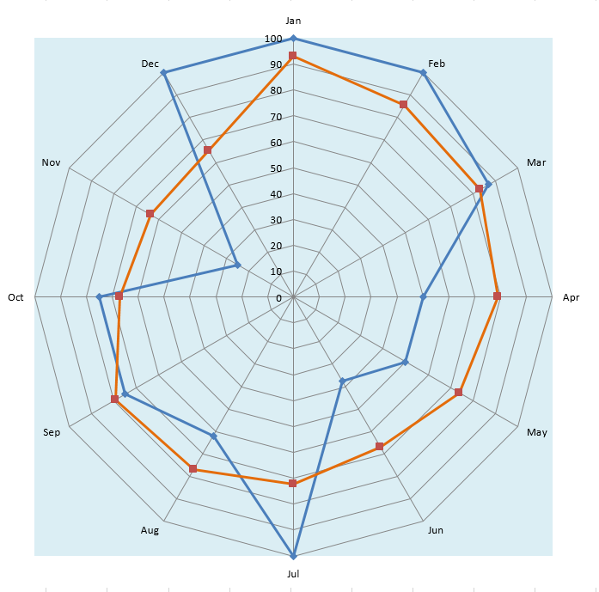 | The attendance records for 2018 were reviewed. Graphical display of attendance was debated with members. It was noted that February’s meeting was moved to early March and the graphs did not reflect to true attendance. The up to date data now shows Bob as achieving 11 meetings which does not include a meeting on his own in February. Richard, Harry and Steve O’c attending 10 and 9 respectively whereas Kim, Steve L and Alan recorded 6 and 5 attendances respectively.  There were 4 months when all members attended and the average attendance thru 2018 was 71% against yearly average of 75.5 %. (see below)
Primary meeting points : Last year’s items

Items that were proposed last year :

- Steve L will arrange another Shooting event, on a Sunday morning for those wishing to attend.
- Steve O suggested a SIT meeting could be at a 20/20 Cricket match at the Ageas Bowl (Hampshire CC)
- Steve O & Steve OL promoted a visit to Cowes during the Lendy Cowes Week sailing regatta.
Dates suggested were Thursday 9th or Friday 10th August
- Alan reminded the membership that we were all agreed on a weekend away and once again was prepared to look into this event and asked everyone for dates that they would not be able to go thru 2018.

From the above proposals only the weekend away took place. This was a visit to Malaga
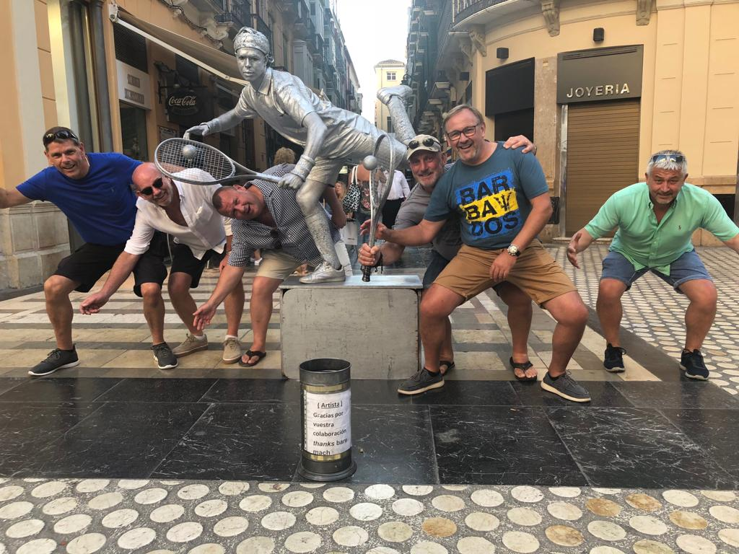
2017 SIT AGM
(Private Gentlemen’s Club est.1995)

 | Secondary meeting points : SIT Account
SIT Account  Members fund | Accounts were shown by Richard, showing contributions, tax and interest for the financial years 2004 - 2018.  The account balance to end of December 2018  Opening balance £7.58  Contributions £38,430.00  Interest £345.49  Bonds Winnings £625.00  Total income £39,708.07  Tax on account -£46.14  Lotto purchases -£680.00  Premium Bonds purchase -£3,000.00  Accounting fees Richard FOC  Fund payout to 7 members (Vegas) -£12,460.00  Fund pay out Cruise / London -£12,488.28  Xmas meal -£702.25  Lotto tickets -£782.00  Loss on Shares -£470.00  Malaga Weekend -£4,525.45  Fund payout to 7 members (Malaga) -£2,100.00  Total outgoings -£37,254.12  Balance in account £2,453.95  Total SIT fund value £5,478.95 of which £3,025 is in Premium Bonds.  This equates to £782.71 per SIT Account member as of 01/01/19  Tertiary meeting points : Open Floor A.O.B.  Steve OL spoke about the SIT members 60th birthdays and what we should do  Conclusion was a weekend away in 2021  In addition a weekend or event with the girls in 2020  Bob asked about the annual Whisky trip. This was confirmed by Richard who announced a likely date would be 11th October 2019. Members wishing to go on this trip to advise Richard as soon as possible.  Bob suggested a day out in Brighton would be good during the warmer months, visiting amongst other establishments craft beer houses.  Harry proposed going to a 20/20 Cricket match at the Ageas Bowl (Hampshire CC) and also a football match at Fratton Park. Play Up Pompey  Kim thanked everyone for their support when he decided not to go on the Malaga trip.
Meeting called to a close.
Meeting minutes written by Richard and checked by Steve O’C 14th Feb 2019
Attendance graph below
