2020 SIT AGM
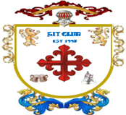
(Private Gentlemen’s Club est.1995)

Venue and date |  | Held at the Northcote Hotel, Francis Avenue, Southsea on 7th February 2020
Gentlemen present |  | Richard, Harry, Steve L, Bob, Steve O’C, Kim, Alan and Steve Ol
Agenda |  | Review of last year’s minutes read by Richard who will then proceeded with the agenda. The Agenda format was as follows :-  Dates for 2020 monthly meetings and Review of 2019 attendance  Primary minutes : discussions on the open items from 2019  Secondary minutes : SIT account fund  Tertiary minutes : open floor A.O.B.  Items For Sales : New for 2020
Dates for 2020  Birthdays  Other dates  St Georges Day | - February  - Friday 21st SIT Meeting : venue Brewhouse & Kitchen (51 Southsea Terrace)  - Steve O’c birthday 15th February 1961  - March  - Friday 20th SIT meeting : venue Albert Road, start at Porters  - April  - Friday 24th SIT meeting : venue Southsea, start at The Greenwich  - Steve Ol’s birthday 14th April 1961  - 23rd St Georges day  - May  - Saturday 9th Special Event : Brighton Day 25th Anniversary  - Friday 22nd SIT meeting : Albert Road, start at Porters  - Harry’s birthday 1st May 1961  - June  - Friday 19th SIT meeting : venue Staggeringly Good, then Albert Road  - July  - Friday 10th SIT meeting : venue Old Portsmouth, start at Still & West  - Richard’s birthday 2nd July 1961  - Alan’s birthday 13th July 1962  - August  - Friday 28th SIT meeting : venue Gunwharf Quays, start at Cosy Club  - September  - Friday 25th SIT meeting : venue Albert Road, start at Porters  - Kim’s birthday September 1960 [60th Birthday]  - Bob’s birthday 27th September 1960 [60th Birthday]  - October  - Friday 30th SIT meeting : venue Brewhouse & Kitchen (51 Southsea Terrace)  - November  - Friday 27th SIT meeting : venue Albert Road, start at Porters  - Steve L birthday 5th November 1960 [60th Birthday]  - December  Friday 11th SIT meeting : venue Craneswater Snooker Club  2021 AGM : Friday 8th January 2021 Venue : Jolly Tax Payer
2020 SIT AGM
(Private Gentlemen’s Club est.1995)

Meeting opened | The meeting opened at the Northcote Hotel, Francis Avenue, promptly at 8:00 with all members present. Suitable comfortable seating in the Lounge bar for discussion and roll call was taken. All members were present and on time.  The meeting was chaired by Richard who duly recorded the minutes.  A suitable kitty was opened for the members and drinks ordered from the lounge bar. Agendas, calendars, and non-audited SIT accounts were handed out for all members to peruse before the start of the meeting.
Review of 2019 attendance  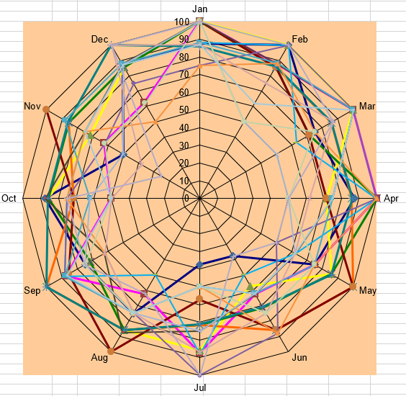 | The attendance records for 2019 were reviewed. Graphical display of attendance was debated with members. It was noted that there may be some data corruption due to Richard losing his spreadsheets and has re-entered data from website incorrectly. Hey Ho. The up to date data shows very good attendance from Richard, Steve O’c Bob, Harry and Steve L. Average attendance from Ol, Alan and Kim; 6, 5 and 3 respectively  The Christmas SIT was a success with Richard, Al, Steve OL and Steve O’c starting early in the Craneswater Snooker club, joined by others members in the Merchant House. Richard, Al, Steve OL and Steve O’c now holding Craneswater Snooker Club membership.
Primary meeting points : Last year’s items

Items that were proposed last year :
- Steve OL spoke about the SIT members 60th birthdays and what we should do
Conclusion was a weekend away in 2021
In addition, a weekend or event with the girls in 2020
- Bob asked about the annual Whisky trip. This was confirmed by Richard who announced a likely date would be 11th October 2019. Members wishing to go on this trip to advise Richard as soon as possible.
- Bob suggested a day out in Brighton would be good during the warmer months. visiting amongst other establishments craft beer houses.
- Harry proposed going to a 20/20 Cricket match at the Ageas Bowl (Hampshire CC) and also a football match at Fratton Park. Play Up Pompey

From the above proposals only the Whisky Trip took place.

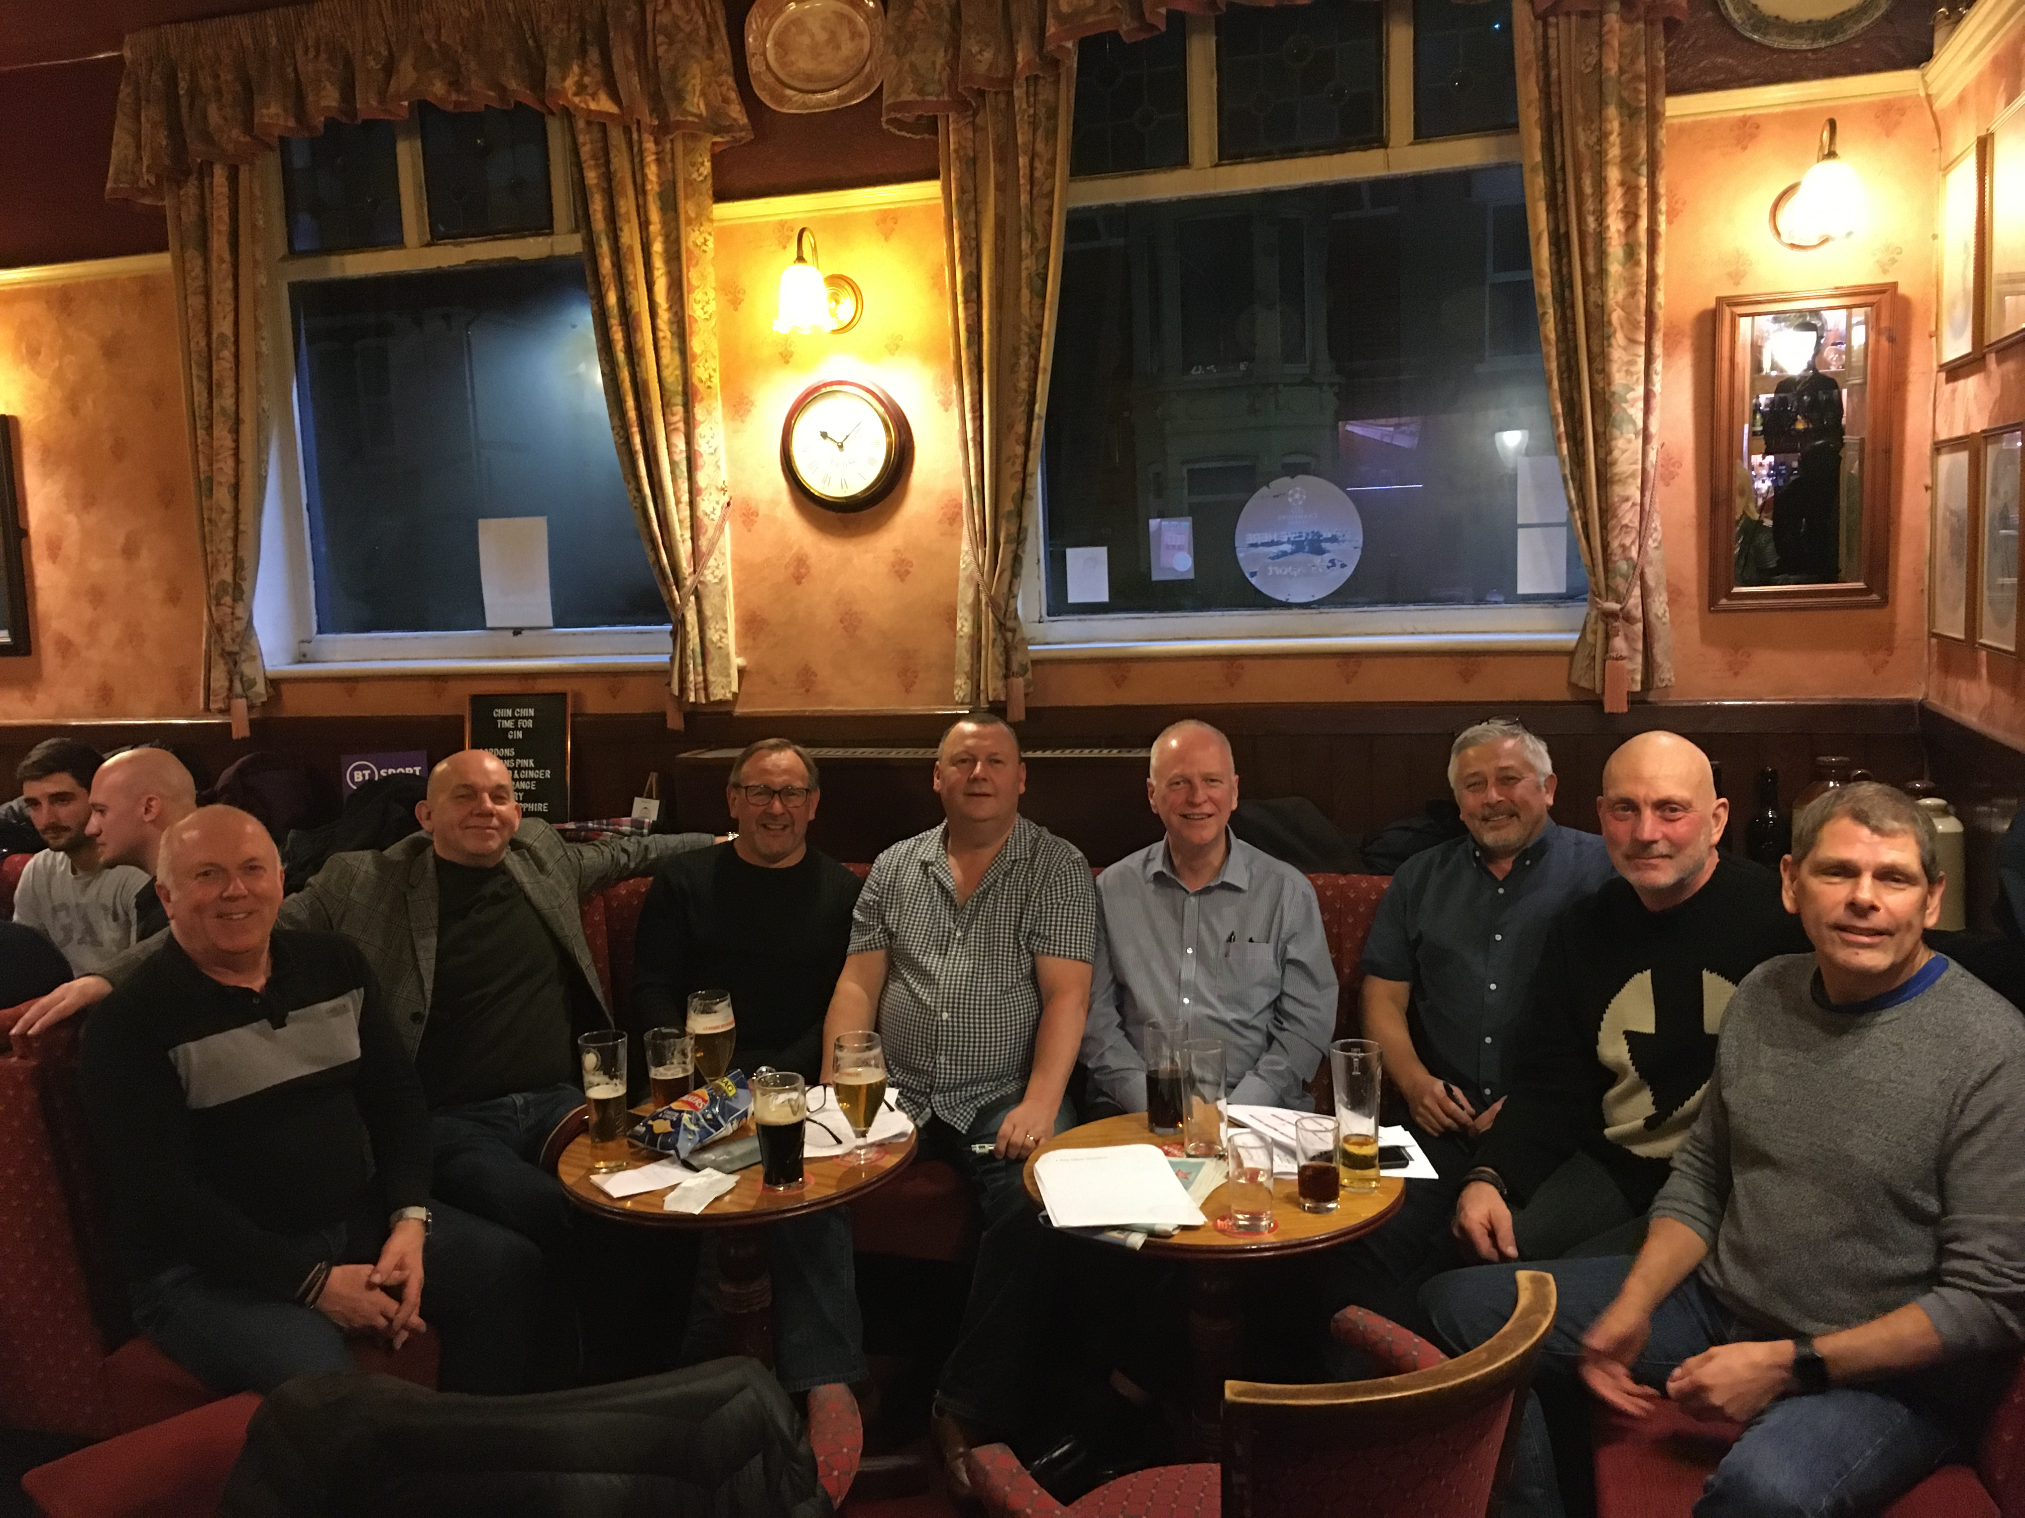
2020 SIT AGM
(Private Gentlemen’s Club est.1995)

 | Secondary meeting points : SIT Account
SIT Account  Members fund | Accounts were shown by Richard, showing contributions, tax and interest for the financial years 2004 - 2019.  The account balance to end of December 2019  Opening balance £7.58  Contributions £41,790.00  Interest £345.49  Bonds Winnings £625.00  Premium Bonds Holdings £3025.00  Total income £45,793.07  Tax on account -£46.14  Lotto purchases -£920.00  Premium Bonds purchase -£3,000.00  Accounting fees Richard FOC  Fund payout to 7 members (Vegas) -£12,460.00  Fund pay out Cruise / London -£12,488.28  Xmas meal -£702.25  Lotto tickets -£782.00  Loss on Shares -£470.00  Malaga Weekend -£4,525.45  Fund payout to 7 members (Malaga) -£2,100.00  Guildhall Experience -£187.00  Total outgoings -£37,681.12  Balance in account £8,111.95  Total SIT fund value £8,111.95 of which £3,025 is in Premium Bonds. (See below)  This equates to £1,158.85 per SIT Account member as of 01/01/20  It was proposed that we should invest the monies we have in the Cahoot account into more premium bonds.  Richard to action £500 hundred at a time  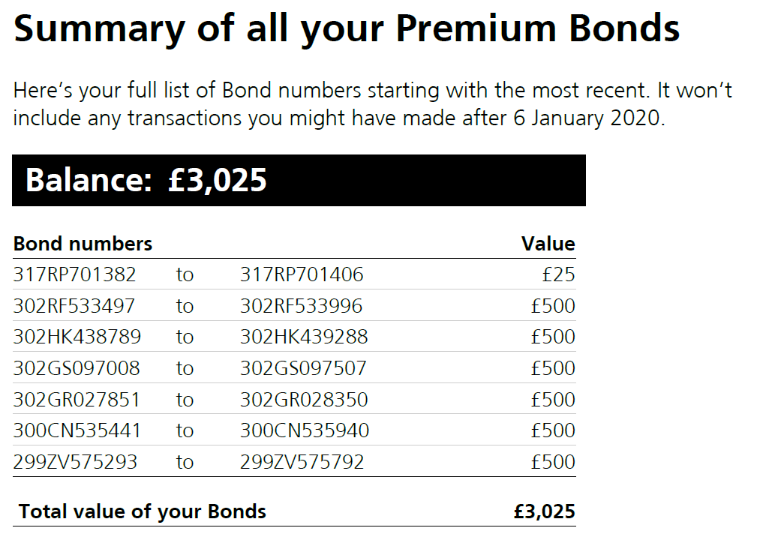  Tertiary meeting points : Open Floor A.O.B.  - SIT members 60th birthdays was discussed in length and the conclusion was for a gathering of all members and wives / girlfriends / plus ones to visit Benidorm in 2021.  Bob added that Jayne Little and other friends were going same time so we should arrange to go the same weekend as Jayne.  Bob to find out dates. Should be March / April 2020  Conesus reached was for all members and girls to go to Benidorm March / April 2021 to celebrate the members 60th Birthdays  - Richard proposed that at each month where a member has a 60th Birthday, the monthly SIT evening can be  - Arranged by that 60 year old SIT member  - To Include a dinner prior to the evening’s events, venue of his choice  - To include a dinner at the end of the evening’s events, venue of his choice  And not have to spend a penny on the evening  - Richard to inform all members of this year’s Whisky trip, where and when  - Steve L will invite members to his 60th Party, venue and date to be confirmed  - Steve O’c has rebooked tickets for England Vs Pakistan on 2nd Sept.  Bob, Harry and Richard showed an interest. The other members rudely declined adding terms like boring  - Steve O’c also suggested a Cowes week trip this year. Steve to follow up.  - Alan suggested a jolly boys day out to celebrate our 25th Year anniversary of the SIT club. After much debate it was agreed that we should travel to Brighton for the day experiencing the delights of the lanes.  After much confusion a date of Saturday 9th May was agreed  - Richard proposed that we move the AGM to the Jolly Tax Payer in Baffin’s village for the 2021 AGM. All agreed.

Towards the end of the meeting and after the meeting was closed Sandra and Sylvia arrived to disrupt the evening with their laughter and interest into the evenings proceedings

There will be posted a reward for the mole who leaked out the AGM address and date

In addition, the AGM for 2021 will be by invite only and treated as a Secret Squirrel

Meeting called to a close.

Meeting minutes written by Richard and checked by Steve O’C 14th Feb 2019

Please see below for

- 60th Birthday Role Call
- Attendance graph below
- For Sale items

Birthday Roll Call

I’m 60 this year

Kim 13th September 1960

Bob 27th September 1960

Steve L 5th November 1960

I’m 60 Next year

Steve O’c 15th February 1961
Steve Ol 14th April 1961
Harry 1st May 1961
Richard 2nd July 1961

I’m 60 soon

Alan 13th July 1962



Items For Sale

High qaulity bathroom rainfall shower head (500mm X 500mm)

Quality stainless steel finish, with spare rainfall nozzles

£125.00 including delivery and installation*

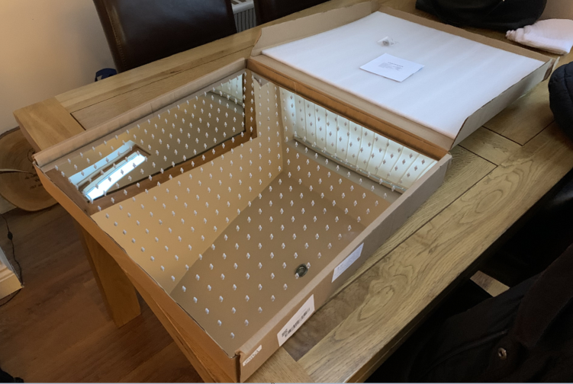
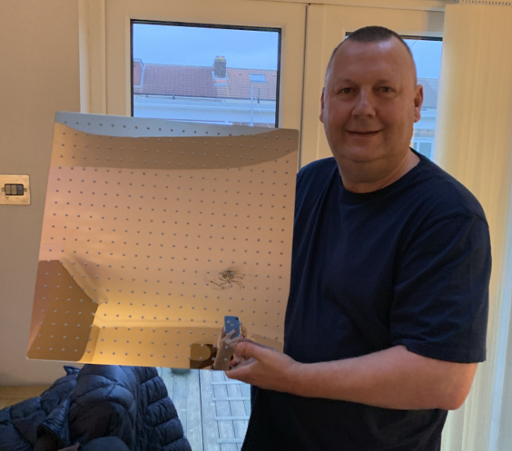

*Installation only carried out after buyer installs suitable, I Beam / RSJ to hold shower head mass estimated at 4.2kg

