SIT Barcelona Trip 2025 –Itinerary

Friday 9th May 2025
16:10 Arrive Barcelona airport
17:30 Arrive at Airbnb (Carrer de l'Argenteria, 21, Barcelona, Catalunya 08003, Spain)
- Dump stuff and stock up on beers, etc.
18:30 Evening walk/drink/eat (see map below)
- Walk towards La Rambla via the Cathedral, possibly stopping at my favourite Pintxos place (Irati) and possibly calling into La Boqueria (a food market in La Rambla, closes 20:30). End up in Plaza Reial, where there are quite a few eating drinking options. There are also eating/drinking options all along the way. In total it’s only a 20 minute walk (without stops).
- 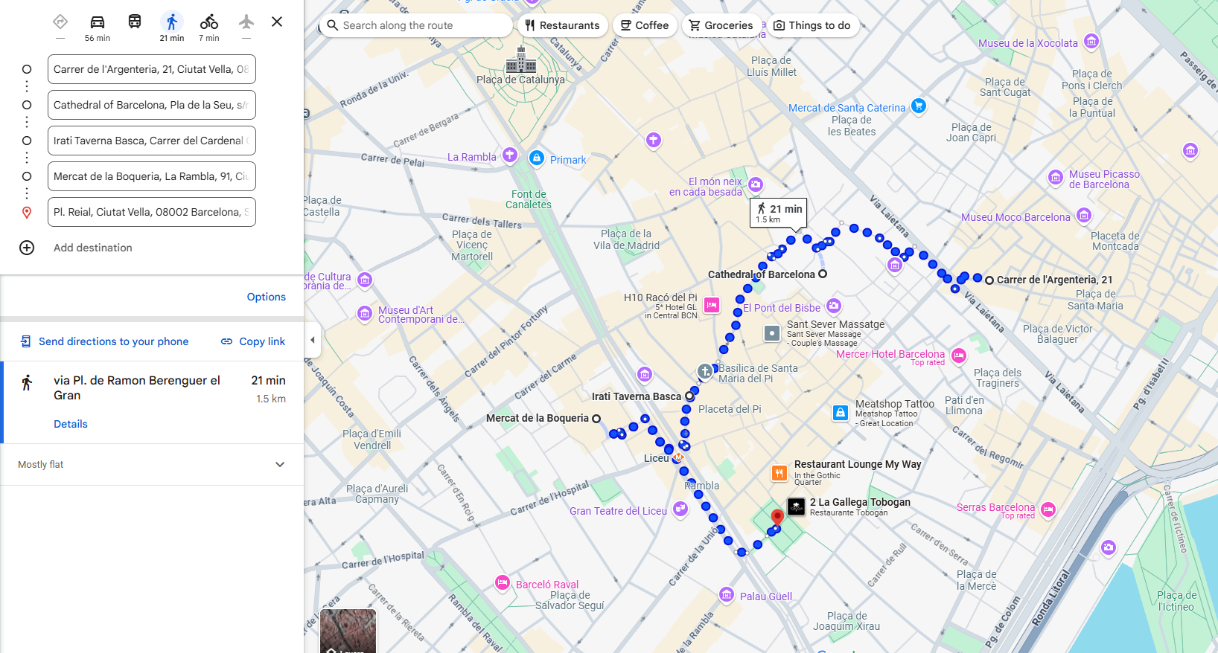

Saturday 10th May 2025
- Bit of breakfast, then get the Hop-on hop-off bus, hopefully before midday (see map below):
  - Take the Red Route on the “Barcelona Bus Turistic”. Get on at Museu D’Historia de Catalunya (11 min walk from apartment) and travel anti-clockwise.
  - Option to get off at La Pedrera and switch to Blue Route (same ticket) to the Sagrada Familia. Look around there and then get back to the La Pedrera (20 min walk or 8 minute taxi) to rejoin the Red Route. Alternatively, we can skip this and do Sagrada Familia on the Sunday (maybe see how the time’s getting on).
  - Continue on Red Route until Miramar-Jardins Costa i Llobera, where we can get the cable car down to Torre San Sebastian, which is close to the beach (Placa del Mar). Although we should probably get off the bus just before that at Anella Olimpica to have a look around the Olympic Stadium. We can either get back on the bus or walk/taxi down to the cable car.
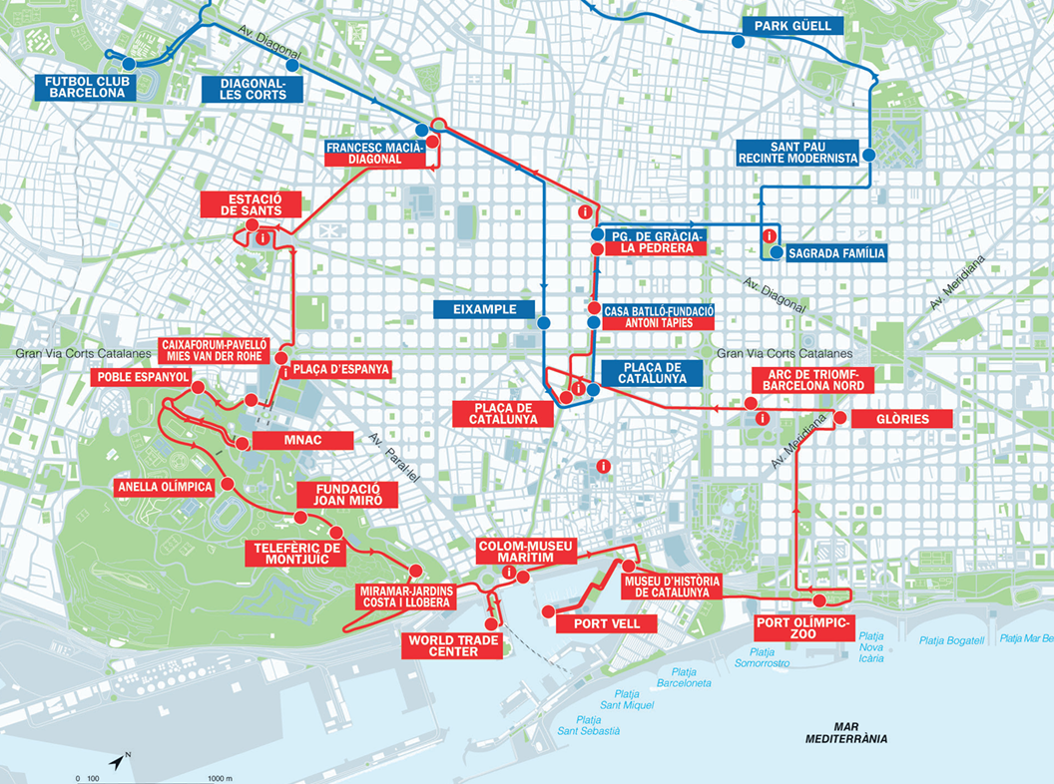
- Camp out at a beach bar in Placa del Mar for a while.
- From Placa del Mar, walk back towards the city and stop at the marina area for more food/drink (map below).
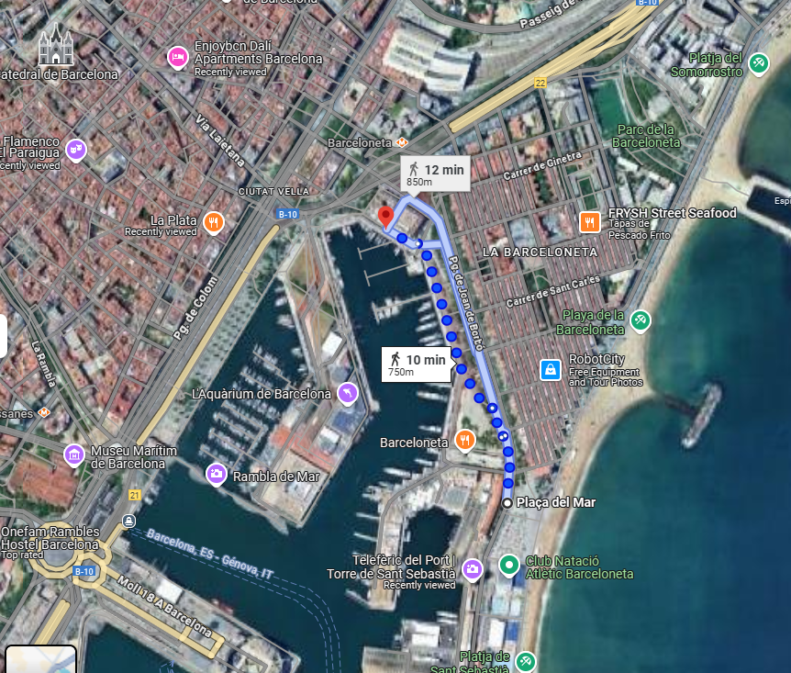
- Play it by ear for the rest of the day - it’s a 10-minute walk back to the apartment through the gothic quarter.

Sunday 11th May 2025
Bit of breakfast, then I’ve laid out a few options below, we can do some or all of these:
- If we didn’t do the Sagrada Familia on the Saturday, this should be our first priority! Travel options are Metro:14 mins; Walk: 42 mins; Taxi: 21 mins
- Re-do something we did and liked on the previous days.
- Unguided walking tour of the Gothic Quarter. Here is a sample itinerary of a paid-for tour (£95/head), which we could just roughly follow on our own (£0/head)? https://www.tripadvisor.co.uk/AttractionProductReview-g187497-d11903975-Devour_Barcelona_Tapas_Taverns_Gothic_Quarter_Food_Tour-Barcelona_Catalonia.html
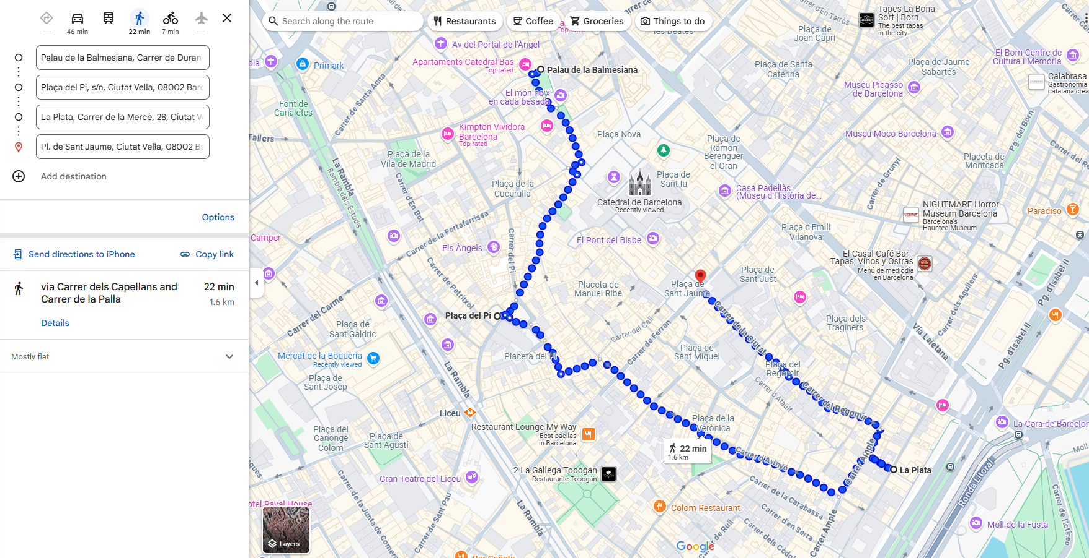
- Flamenco show (not sure about this one!)
  - There are a few of these, they tend to last 1-2 hours, but they tend to be in the evening… so not sure that will work? If anyone else is interested I can do more research (the one I was thinking of Tablao Flamenco El Paraigua is not available on this day).
- El Clasico
  - Barcelona are playing Real Madid at the Olympic Stadium (the Camp Nou is being refurbished). Kick-off was originally 21:00 but has been moved to 16:15. We’ve ruled out going to the game (cheapest tickets are €409) but it would be fun to watch it in a bar somewhere.

Monday 12th May 2025
Taxi from the apartment at 10am to get us to the airport by 10:40, for our flight home at 12:40.

